Introduction
You have been registered in an Epic Instructor Led Training (ILT) Course. Due to the COVID-19 situation, this course has been converted to a virtual learning experience. In order to receive credit for completing the ILT course and gain access to Epic, completion of the eLearnings and post-test is required. This tip sheet will help you locate those items in the TO DO tab of My Learning and Performance.

Instructions

Go to the To Do tab. You can filter to find the course by clicking on the Assigned Learning tab.

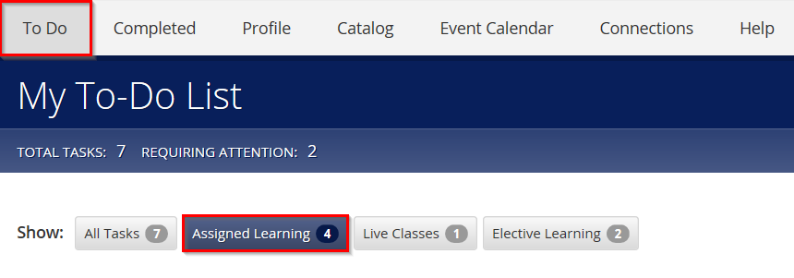

Locate the Epic courses that you are enrolled in: Epic Ambulatory Physician (eLearnings) & Epic Ambulatory Primary Care Provider. Click on the course title or on the Start button.

eLearning

Begin with the eLearnings course. Estimated total time to complete this is 1 hour. Each eLearning will unlock as you complete the one before. When all are complete, return to your To Do tab.
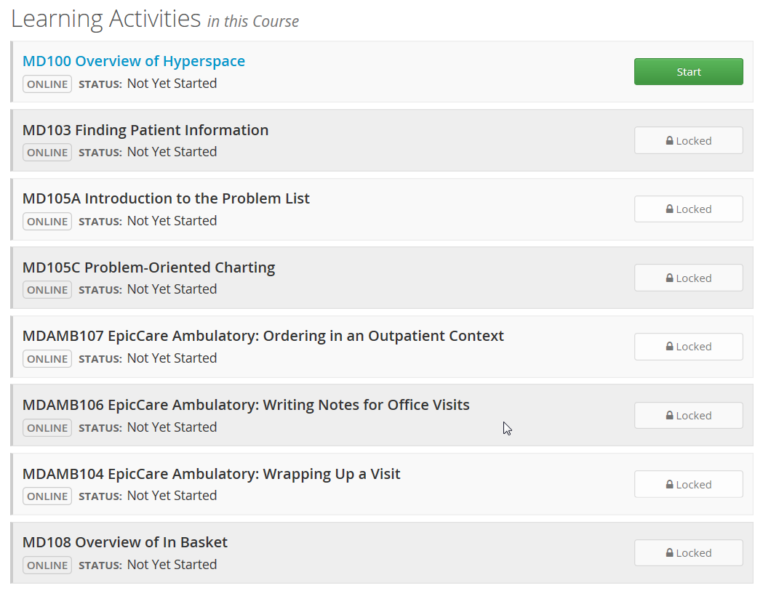

Post Test

After you have attended your virtual class, Start the Provider course.

If you have not already previously opened the course, there will be an option to View and Open the Class Guide and Exercises. Click the green Open button.

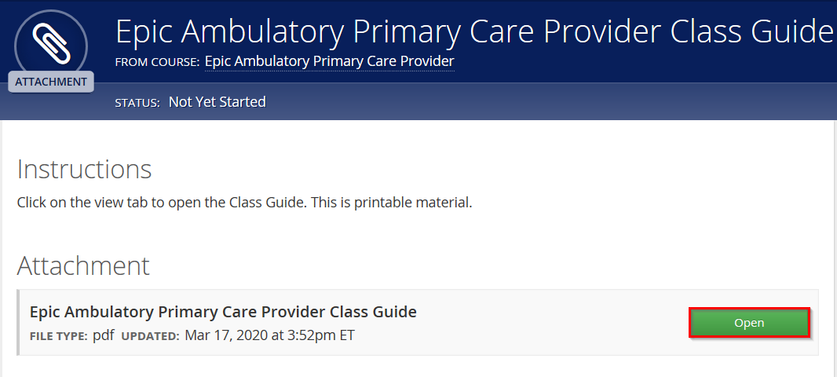

If you are in Chrome, the attachment will pop up at the bottom of the screen. You can open and print or save as needed. This will be the same for the Exercises document.

If you are in Internet Explorer, a dialogue box will pop up. Click the open button.

After you open and save or print the documents, a Course Attachment box will pop up asking if you have completed the documents. Click – Yes, Mark it complete.

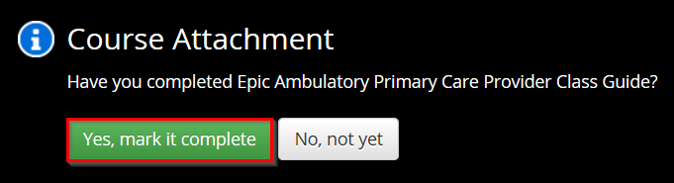

After opening the Class Guide and Exercises documents, and after the virtual class session has been graded by your instructor, the Post-Test will be available to start.

Click on the course title, and then the green START button to open the test.

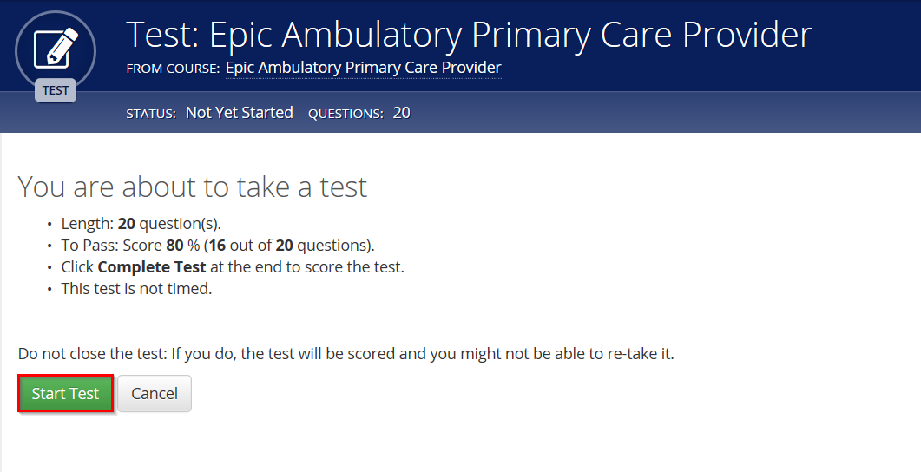

After successful completion of the test, the ILT course will then transfer over to your Transcript/Completed tab with the estimated class time.

